**FABIAN LEFEVRE**

**HOMEWORK REQUIREMENTS**

Do the same for your Google Cloud Microinstance. That server should always be online (as it is a microinstance, it should be free and never impact your overall credits). That server will host your project webpage.

The Google server should have the following page:

1. An index page (landing page) that describes your overall project, including:
   1. A list of all the members of your team
   2. A description of your project
      1. Make sure the overview is appropriate for a grade school audience

Eventually, this will be updated with instructions for accessing/running your service.

**REPORT REQUIREMENTS**

**50 points total**

For your submission, you can copy and paste the following into a new document.

* [4 points] Copy and paste a **screenshot** of the default Apache webpage that you took in Step 1.1

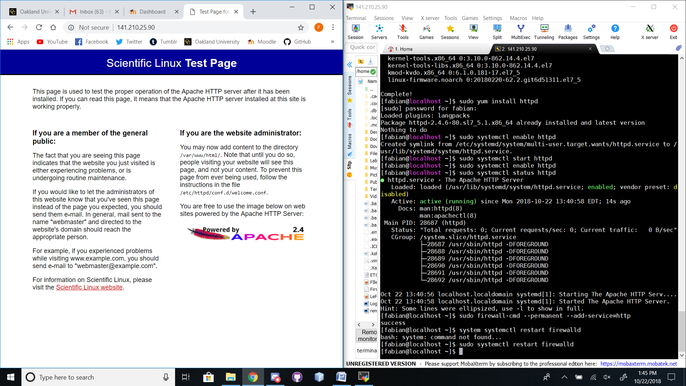

* [6 points] Why do you need to **start** and **enable** the **httpdservice?**

**I needed to do this so the http/Apache service would be running on the machine. This makes it so the microinstance has an External IP address that can be reached by my browser.**

* [6 points] Do a Google search (or look in your book) at the **firewall-cmd** command. What is the purpose of this command, and why do you need to run it?

**The purpose of the firewall-cmd command is to provide an interface to manage runtime and permanent configuration for the firewalld daemon. It needs to run because the system won’t have an external IP address without doing so.**

* [3 points] Why do we need to run the **mysql_secure_installation** command after installing MySQL?

**We need to run this command so that MySQL has all its presets configured, such as root password.**

* [6 points] What are **two** differences between MariaDB and MySQL? Provide your source.

**Two differences between MariaDB and MySQL are:**

1. **MySQL doesn’t encrypt temporary tablespace or binary logs. MariaDB Does.**
2. **MariaDB supports Invisible Columns, while MySQL doesn’t.**

**SOURCE:** [**https://www.eversql.com/mariadb-vs-mysql/**](https://www.eversql.com/mariadb-vs-mysql/)

* [5 points] Place your screenshot of the PHP settings page here:

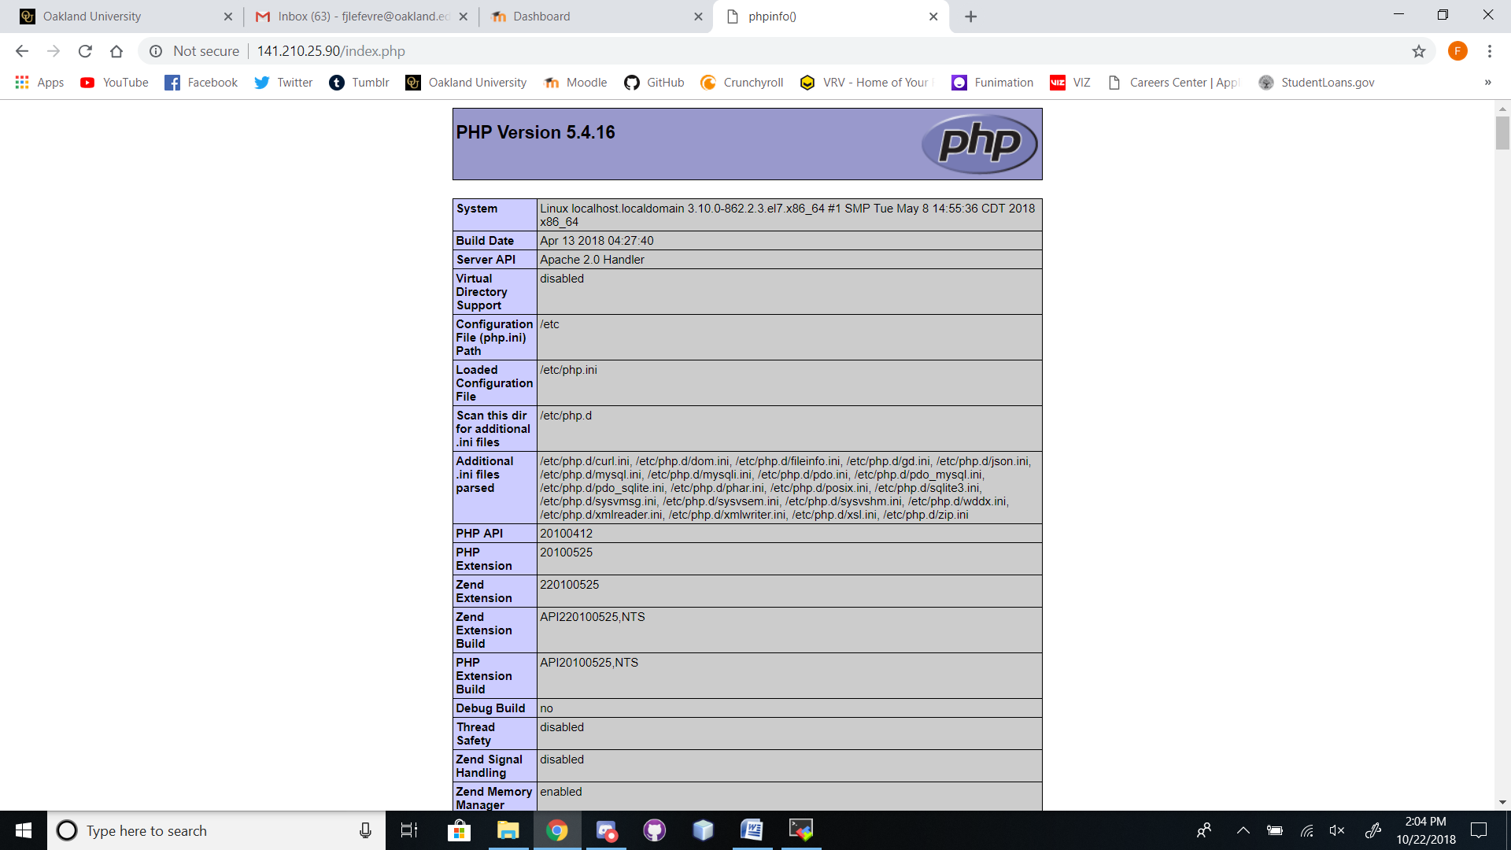

* [20 points] Provide the **external** IP address of your Google website and a screenshot of it.

**35.237.103.49**

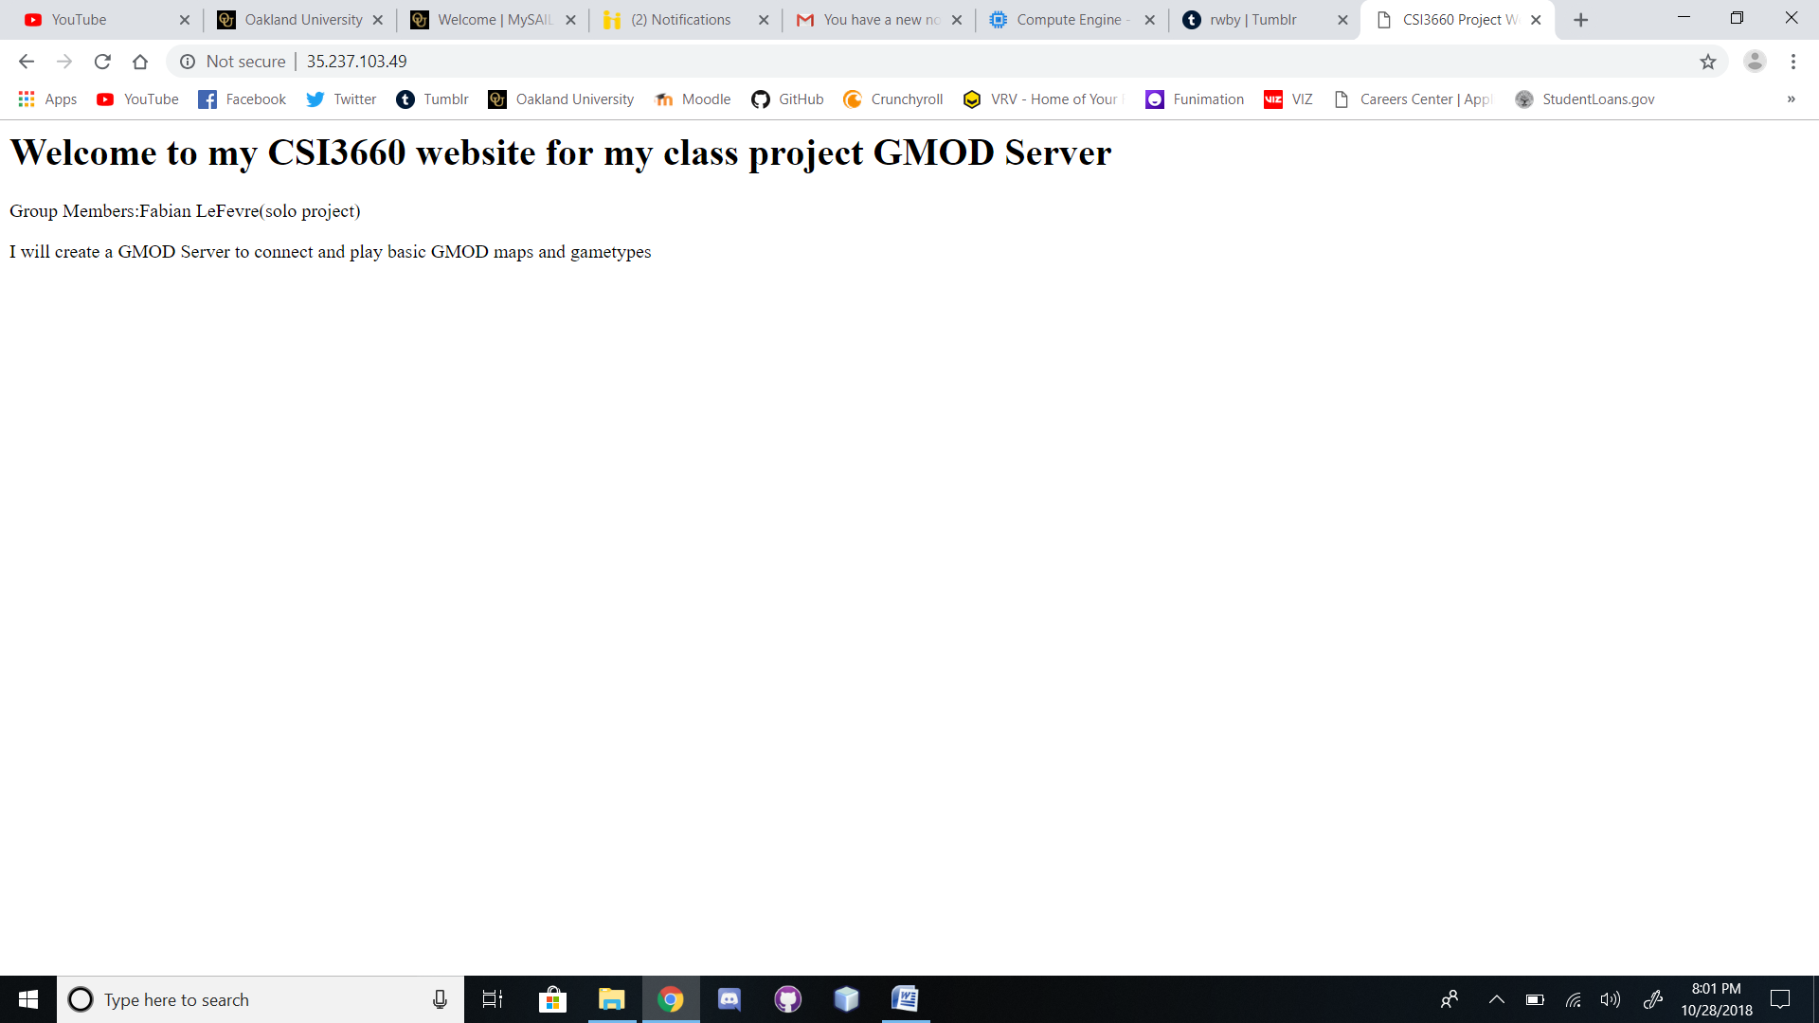

**Extra Credit:**

(10 points) Setup phpMyAdmin and demonstrate it working.